**DAILY ONLINE ACTIVITIES SUMMARY**

|  |  |  |  |  |  |  |  |  |
| --- | --- | --- | --- | --- | --- | --- | --- | --- |
| **Date:** | **08-06-2020** | | | | | **Name:** | **Preethi** | |
| **Sem & Sec** | **6th - B** | | | | | **USN:** | **4AL17CS065** | |
| **Online Test Summary** | | | | | | | | |
| **Subject** | | **CNSC** | | | | | | |
| **Max. Marks** | | **60** | | **Score** | | | **36** | |
| **Certification Course Summary** | | | | | | | | |
| **Course** | **Python for Data Science** | | | | | | | |
| **Certificate Provider** | | | **Cognitive Class-IBM**  **DeveloperSkillsNetwork** | | **Duration** | | | **7hours** |
| **Coding Challenges** | | | | | | | | |
| **Problem Statement:1 C++,1 C,1 Java and 1 Python program** | | | | | | | | |
| **Status: executed** | | | | | | | | |
| **Uploaded the report in GitHub** | | | | | **Yes** | | | |
| **If yes Repository name** | | | | | <https://github.com/PreethiNayak/Daily-Status/tree/master/08June2020> | | | |
| **Uploaded the report in slack** | | | | | **Yes** | | | |

Online Test Details: (Attach the snapshot and briefly write the report for the same)

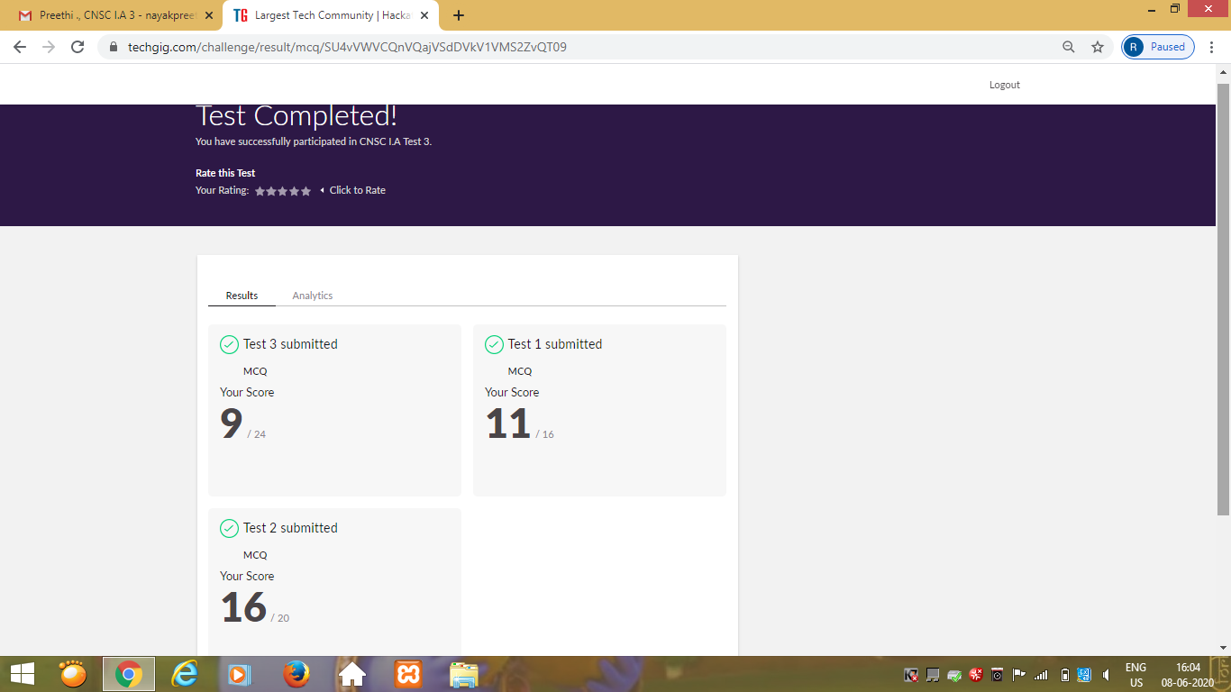

Certification Course Details: (Attach the snapshot and briefly write the report for the same)

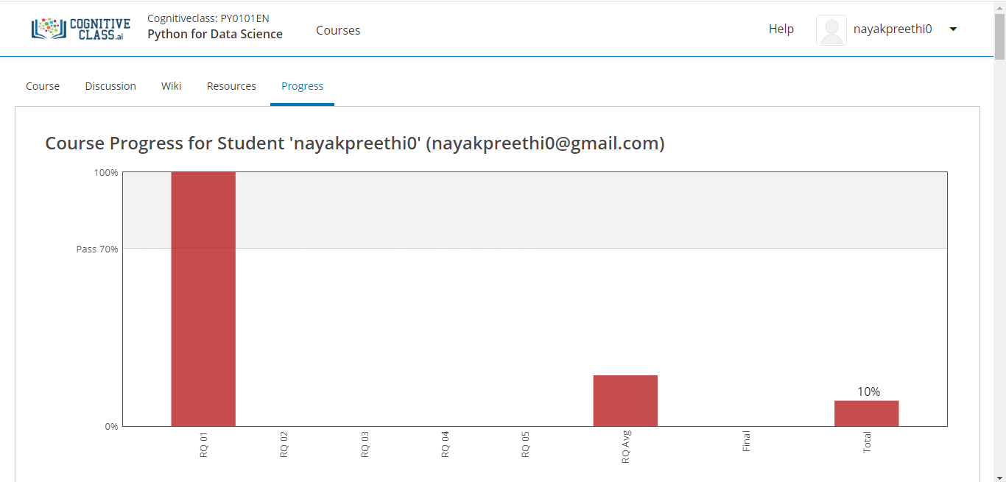

Today I started “Python for Data Science” course.

I completed module 1-“Python Basics”.

In that I studied,

-Expression and Variables.

-String Operations.

-attempted Quiz on this module.

Coding Challenges Details: (Attach the snapshot and briefly write the report for the same)

Program 1

This is output of C++ program to check whether a number can be represented as difference of two squares.

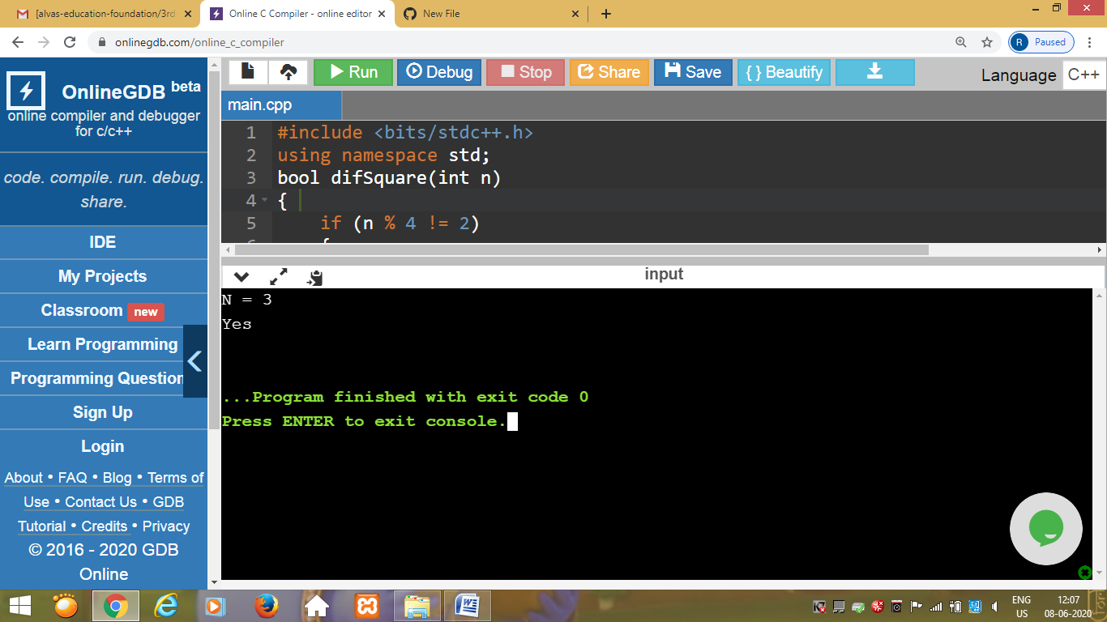

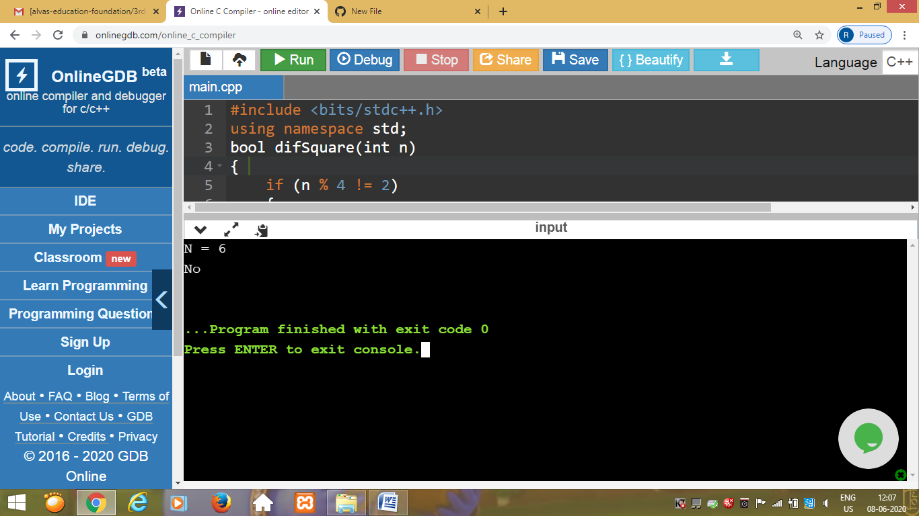

Program 2

This is the output of the C program to generate All the Set Partitions of n Numbers Beginning from 1 and so on.

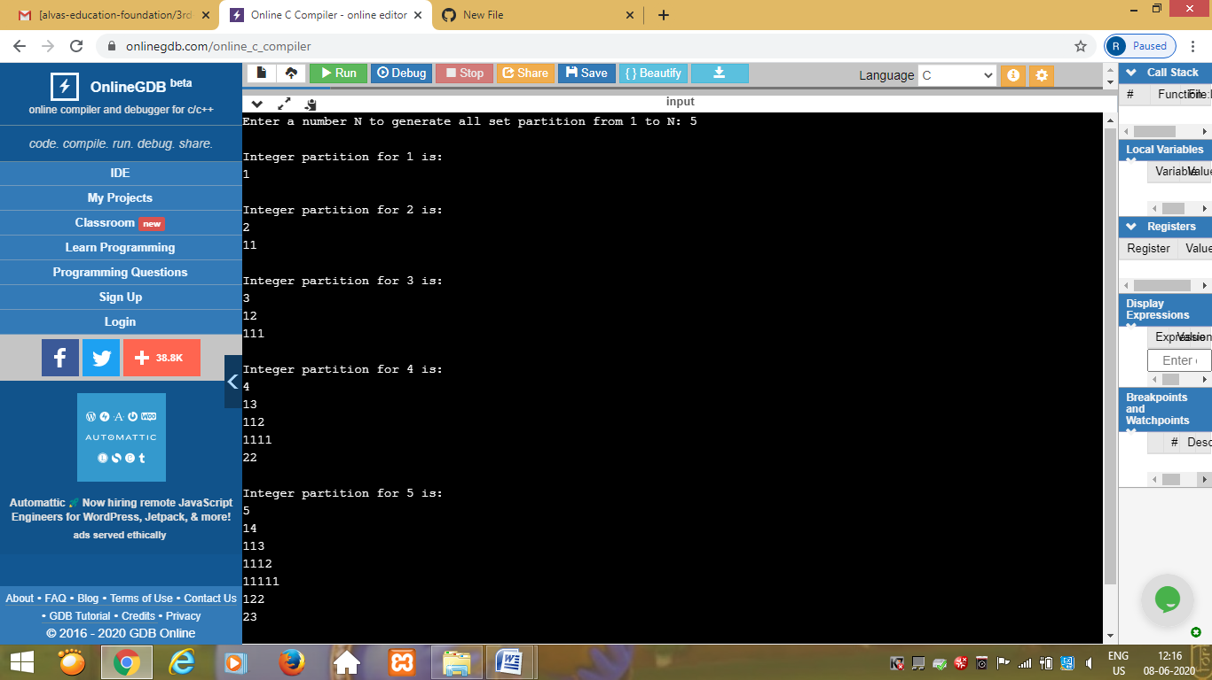

Program 3

This is the output of Java program to delete a node from the middle of the singly linked list.

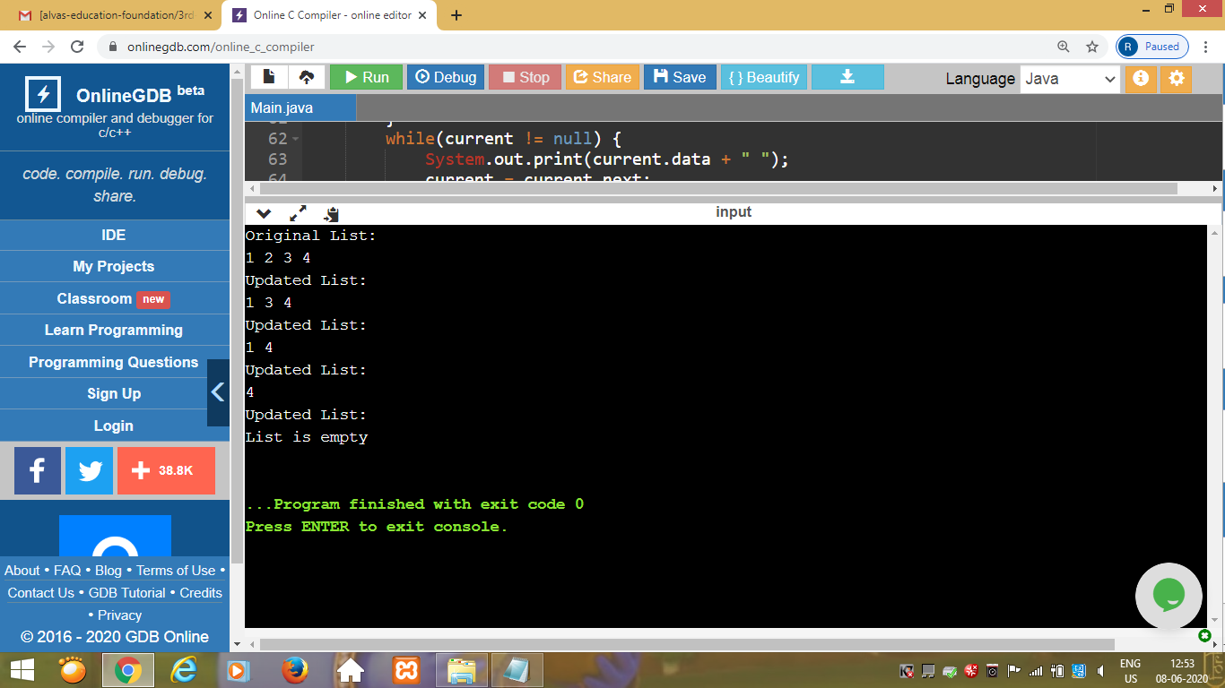

Program 4

This is the output of Python program to find whether a string is a palindrome or not.

